LLM Transformer Architecture
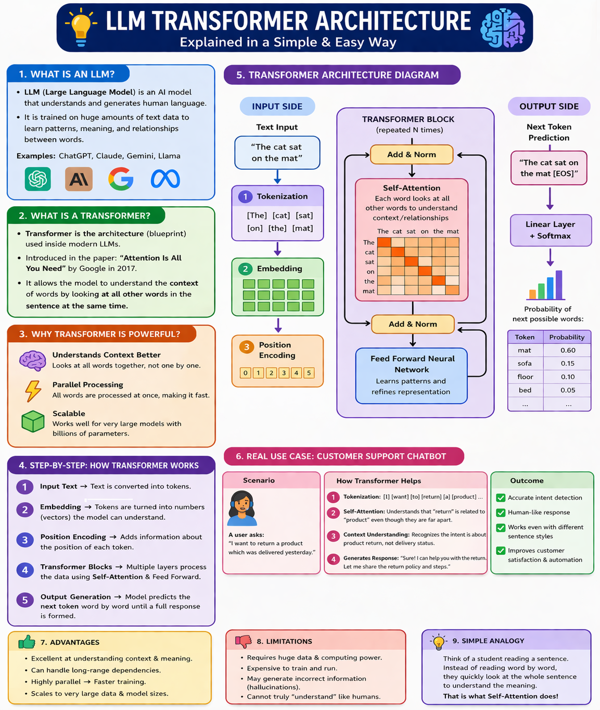
Figure 1. Visual overview of LLM Transformer Architecture
Quick idea: A Large Language Model (LLM) is the AI system, and the Transformer is the core architecture that helps it understand context and generate meaningful text one token at a time.

1. What is an LLM?
- LLM stands for Large Language Model.
- It is an AI model trained on a very large amount of text so it can understand patterns in language and generate useful responses.
- LLMs can answer questions, summarize content, translate text, write code, and support chat-based interaction.
- Examples include ChatGPT, Claude, Gemini, and Llama.

2. What is a Transformer?
- A Transformer is the main architecture used inside most modern LLMs.
- You can think of it as the blueprint or engine design that allows a language model to process text efficiently and understand relationships between words.
- Before Transformers, older sequence models often processed words one by one and had more difficulty with long context. Transformers improved this significantly.

3. Why was the Transformer introduced?
- Older NLP models such as RNNs and LSTMs processed words sequentially, which made training slower and long-range context harder to capture.
- For example, in a long sentence, the meaning of a word at the end may depend on a word at the beginning. Traditional models often found such relationships harder to learn.
- The Transformer addressed this problem by introducing self-attention, which allows each word to look at other words in the same sentence.

4. Main idea behind the Transformer
- The key idea is self-attention: each token can look at all other relevant tokens in the sequence to understand context.
- Instead of reading a sentence strictly one word after another, the model can consider the whole sentence and decide which words matter most for meaning.
- This is why Transformers are much better at capturing context, grammar, and long-distance relationships.

5. Step-by-step flow of Transformer processing
Step | Component | What happens
1 | Input Text | The user provides text such as “I want to return the product.”
2 | Tokenization | The sentence is split into smaller pieces called tokens.
3 | Embeddings | Each token is converted into a vector of numbers the model can work with.
4 | Positional Encoding | Position information is added so the model knows token order.
5 | Self-Attention | Each token looks at other tokens to understand meaning and relationships.
6 | Feed Forward Network | The representation is refined using neural network layers.
7 | Repeated Transformer Blocks | Multiple layers repeat the process and deepen understanding.
8 | Output Generation | The model predicts the next token and continues until a full response is formed.

6. Core components in simple words
- Tokenization: Splits text into smaller language units.
- Embeddings: Converts tokens into numeric vectors that carry meaning.
- Positional Encoding: Adds order information so the model understands sequence.
- Self-Attention: Helps each token decide which other tokens are important.
- Query, Key, Value: Internal representations used to calculate how much attention one token should give another.
- Multi-Head Attention: Allows the model to look at the same sentence from multiple perspectives at the same time.
- Add & Norm: Stabilizes learning and helps preserve useful information across layers.
- Feed Forward Network: Further processes the attended information to improve the representation.

7. Real-world use case 1: Customer support chatbot
- A customer types: “I want to return a product that was delivered yesterday.”
- The model tokenizes the sentence, converts tokens into embeddings, and applies self-attention.
- It learns that “return” is strongly related to “product” and “delivered yesterday,” so it detects the correct intent.
- The chatbot can then generate a response such as: “Sure, I can help you return the product. Please share your order ID.”
- Outcome: faster support, reduced manual workload, and improved customer experience.

8. Real-world use case 2: Document summarization
- A user uploads a long report and asks for a summary in five points.
- The Transformer processes the document, identifies the most important ideas, and captures relationships across many sentences.
- It then generates a short summary that preserves the main meaning of the longer content.
- Outcome: major time savings, better productivity, and easier understanding of long documents.

9. Real-world use case 3: Code assistant
- A developer asks: “Write a Java method to reverse a string.”
- The model understands the programming language, the requested task, and the expected output format.
- It generates code token by token in a structured way.
- Outcome: faster development, learning support, and productivity gains.

10. Encoder and Decoder
- In the original Transformer architecture, the encoder reads and understands input, while the decoder generates output.
- Encoder-only models are common for understanding tasks such as classification or search.
- Decoder-only models are common for generation tasks such as chat, completion, and coding assistance.
- Encoder-decoder models are common for tasks like translation and summarization.

11. Parameters and training
- Parameters are the internal learned values of the model. They store what the model has learned from training data.
- During training, the model predicts the next token, compares it with the correct token, calculates error, and adjusts its internal weights.
- This process repeats many times across huge datasets until the model becomes good at language prediction and generation.

12. Simple analogy
- Imagine a student reading a sentence. An older model may read one word at a time and gradually forget earlier words.
- A Transformer quickly looks across the sentence and sees how all the words connect.
- That broader view is exactly why self-attention is so effective.

13. Advantages and disadvantages
Advantages | Disadvantages
• Strong context understanding | • Requires large amounts of compute and memory
• Parallel processing during training | • Training is expensive
• Handles long-range relationships better | • May generate incorrect information
• Scales well to very large models | • Needs high-quality data
• Supports chatbots, translation, summarization, and code generation | • Does not reason exactly like a human

14. Final summary
In one line: An LLM is the language model, and the Transformer is the architecture that helps it understand context through self-attention and generate meaningful text one token at a time.

